Phishing Awareness Simulation Using Social Engineering Techniques
Major Project Report
Name: Arya Amar Badhe
Course: Cyber Security
Organization: Naviotech Solutions Pvt Ltd
Date: 14/04/2026

1. Introduction
Phishing is a major cybersecurity threat that exploits human psychology to steal sensitive information.

2. Methodology
- Researched phishing techniques
- Designed phishing email
- Created fake login page
- Conducted simulation
- Collected and analyzed data

3. Results
- Users clicked phishing links
- Some entered credentials
- Few detected phishing

4. User Behavior Analysis
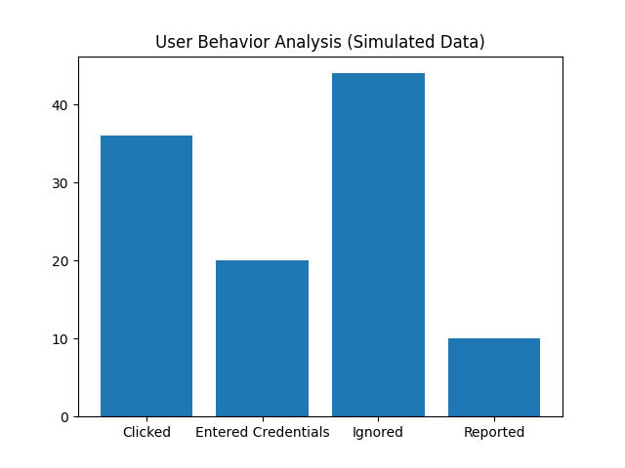
Data based on simulated environment.

5. Preventive Measures
- Enable MFA
- User awareness training
- Email filtering
- Report suspicious emails

6. Ethics and Safety
- Conducted with consent
- No real data collected
- For educational purposes

7. Conclusion
Awareness and training are key to preventing phishing attacks.
8. Screenshots
